EVS Project
Air and Noise Pollution during Diwali
Vignesh Sivakumar
Srivathsa PV
Yuva A
Velkumaresan M

II CSE “B”

Introduction
Air pollution is the introduction of chemicals, particulate matter, or biological materials that cause harm or discomfort to humans or other living organisms, or cause damage to the natural environment or built environment, into the atmosphere.
From cigarette smoke to global warming, air pollution has many different causes and affects us in many different ways. Pause a moment to make a list of all the different types of air pollution you come across in a single day and you might be surprised. How about car exhausts or garden bonfires, rotting food on landfills, forest fires caused by accident or arson, or fumes from factories?
Environmental noise pollution, a form of air pollution, is a threat to health and well-being. It is more severe and widespread than ever before, and it will continue to increase in magnitude and severity because of population growth, urbanization, and the associated growth in the use of increasingly powerful, varied, and highly mobile sources of noise. It will also continue to grow because of sustained growth in highway, rail, and air traffic, which remain major sources of environmental noise. The potential health effects of noise pollution are numerous, pervasive, persistent, and medically and socially significant.

Ecological Effects of Air Pollution
- Ecological effects of air pollution: Links to numerous detailed reports at California's Air Resources Board.
- Impacts of air pollution on crops and forests: Detailed scientific report from York University UK.
- Air pollution's toll on forests and crops: According to the World Resources Institute, the scientific evidence is growing that air pollution (primarily ozone and acid deposition) is causing extensive damage to vegetation in both Europe and the United States.
- Ill winds: Airborne pollution's toll on trees and crops: This World Resources Institute report summarizes forest and crop damage in the United States and Europe, examines the evidence connecting it to air pollution, and recommends that emissions of nitrogen oxides, sulfur oxides, and hydrocarbons be significantly reduced and non-fossil energy sources introduced.
- Ecological effects of air pollution: A 2005 paper/illustrated presentation by Bridget Emmett, Centre for Ecology and Hydrology (PDF).
- Air pollution impacts on crops and forests: an introduction: by Dr Lisa Emberson of York University.
- The Effects of Environmental Pollution on North American Temperate Forests: A review by Melissa Kaplan.
- Crop archive shows pollution link: A 2005 BBC News story describing how air pollution affects fungal diseases in wheat.
- Smog crop damage costs billions: A 2002 New Scientist news story looks at the ecological cost of smog.
- The cost of crop damage by air pollution from motor vehicles: A 1999 report by James Murphy et al of the University of Arizona concludes pollution causes billions worth of damage.

Chemicals in Air Pollution

- Toxic air pollutants: The US EPA's web pages about the toxic chemicals in air pollution.
- Pollutants: Information from Environment Canada. Covers Criteria Air Contaminants and related pollutants (e.g. SO2, NO2, Volatile Organic Compounds, etc), Persistent Organic Pollutants (POPs)(e.g. dioxins and furans), Heavy Metals (e.g. mercury, and other toxics
- Taking toxics out of the air: A detailed brochure published by the US EPA.
- Particles and particulates: A handy table of the different particles from Environmental Protection UK.
- Scorecard: The Pollution Information Site: Information and statistics about polluting companies in the United States.
- Volatile organic compounds: Sources of indoor air pollution; information from the US EPA.
- Volatile organic compounds: Background information from California's Indoor Air Quality Program.
- Common indoor air pollutants: A 2004 article from the San Francisco Chronicle.
- Hazardous products in the home: A great site from Purdue, with a "clickable" house showing the toxics you're likely to find in each room.
- Heavy metals: Information from UNEP.
- Persistent organic pollutants (POPs): Background information from UNEP.
- Six Common Air Pollutants: The US EPA describes the major air pollutants: Ozone, Particulate Matter, Carbon Monoxide, Nitrogen Oxides, Sulfur Dioxide, and Lead.

Case Study – Air Pollution during Diwali

Chennai:
Diwali celebrations resulted in high levels of air pollution in many parts of the city. According to the Tamil Nadu Pollution Control Board (TNPCB), which continuously monitored the ambient air quality from November 3 to 8, respirable suspended particulate matter (RSPM) levels were much higher than permissible levels on those days.
The National Air Monitoring Programme identifies four air pollutants viz, sulphur dioxide (SO2), oxides of nitrogen (NO2), suspended particulate matter (SPM) and respirable suspended particulate matter (RSPM/PM10). The permissible limit of RSPM/PM10 is 100 ug/m3 as per the ambient air quality monitoring standards. Similarly, the permissible limit for NO2 and SO2 is 80 ug/m3, and that of SPM is 200 ug/m3.
The places monitored for their ambient air quality were Kodambakkam High Road , Nandanam , Koyambedu Bus Stop (CMBT), Moola Kadai (police station), Besant Nagar, Sholinga Nallur.
P K Palanisamy, Chennai regional officer of the TNPCB, said, "The ambient air quality of Koyambedu High Road and other places are monitored twice a week on a routine basis. However, during Diwali, we added other locations to this list. On an average, the RSPM concentration exceeded the prescribed standards during the festival. This can be attributed to bursting firecrackers, including aerial crackers and sparklers."
Palanisamy said that in all cases, the SO2 concentration was observed to be within the prescribed limit of 80 ug/m3. "However, the concentration of SO2 during Diwali increased as compared to its usual levels ascertained through routine monitoring. Fireworks contain sulphur, which gets oxidized to sulphur dioxide later," he said.
Similarly, in the case of NO2, its concentration was well within the prescribed limit of 80 ug/m3, but was found to be higher this time, than what it is during routine monitoring. "The chemicals present in firecrackers increased the concentration of NO2 in the air," added Palanisamy.
On November 3, the level of PM10 was estimated as 117 ug/m3 in Kodambakkam High Road the PM10 levels escalated to 123 ug/m3 in KHR, 191 ug/m3 near the TNPL building, 241 ug/m3 in North Usman Road, 199 ug/m3 in Besant Nagar, 148 ug/m3 in Sholinga Nallur.

Ecological Effects of Noise Pollution
- Noise health effects are both health and behavioral in nature. The unwanted sound is called noise. This unwanted sound can damage physiological and psychological health. Noise pollution can cause annoyance and aggression, hypertension, high stress levels, tinnitus, hearing loss, sleep disturbances, and other harmful effects. Furthermore, stress and hypertension are the leading causes to health problems, whereas tinnitus can lead to forgetfulness, severe depression and at times panic attacks.
- Chronic exposure to noise may cause noise-induced hearing loss. Older males exposed to significant occupational noise demonstrate significantly reduced hearing sensitivity than their non-exposed peers, though differences in hearing sensitivity decrease with time and the two groups are indistinguishable by age 79. A comparison of Maaban tribesmen, who were insignificantly exposed to transportation or industrial noise, to a typical U.S. population showed that chronic exposure to moderately high levels of environmental noise contributes to hearing loss.
- High noise levels can contribute to cardiovascular effects and exposure to moderately high levels during a single eight hour period causes a statistical rise in blood pressure of five to ten points and an increase in stress and vasoconstriction leading to the increased blood pressure noted above as well as to increased incidence of coronary artery disease.

Case Study – Noise Pollution during Diwali

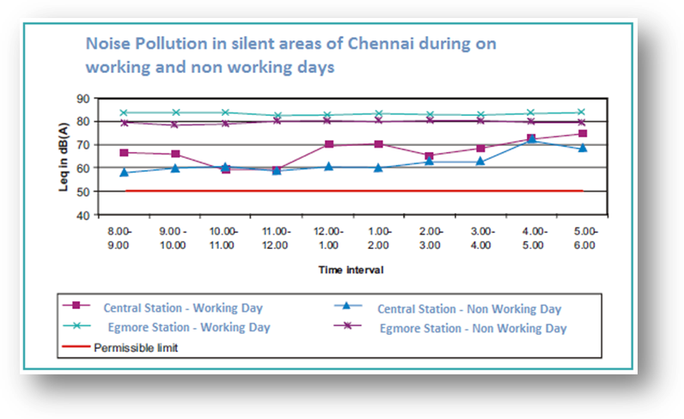
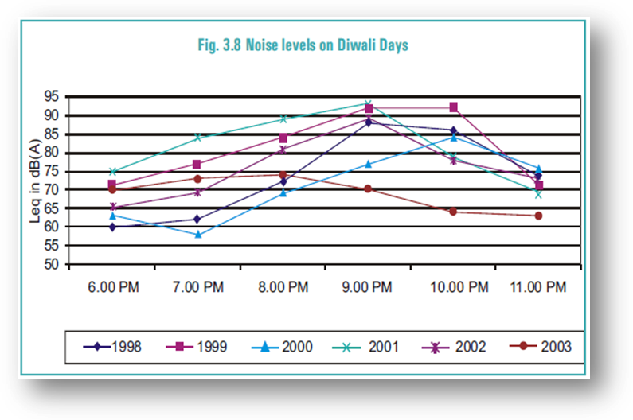

TNPCB has been regularly monitoring noise levels on Diwali nights at the residential areas near Central Railway Station and Egmore Railway Station since 1998. This is one of the oldest and densely populated sectors of the city. Data indicates that noise levels during the evenings of Diwali exceed the permissible limit at each measurement. However, there appears to be a decrease in noise levels from 2001 onwards. This could probably be due to higher awareness about adverse effects of air & noise pollution amongst the general public. This aspect, however, needs to be verified.

Further, during the year 2003, CPCC measured noise levels at various sites in and around Chandigarh one day before Diwali and another on the Diwali day. The figure depicts that the ambient noise levels on Diwali day are far higher than the pre-Diwali day values at all sites. In some cases the noise levels have even exceeded 90 dB(A) which is considered to be harmful for physiological well being of people. Another interesting observation was higher levels of noise on Diwali day at Saligramam, followed by Koyambedu and Perambur, all these sites being suburbs of the city. This could be attributed to lower buffering of noise due to lesser number of trees as well as canyon effect.

